Assignment 1
ML System Optimization

Distributed k-Means Clustering for Large-Scale Customer Segmentation

Team – Group 51
Name | Roll Number | Contribution (Phrased for System Optimization)
Thomala Priyank Kumar | 2024AC05058 | Literature Survey & Sub-domain Analysis
Diya Roy | 2024AC05018 | Mathematical Problem Formulation
Raj Singha | 2024AC05771 | Theoretical Performance & Cost Analysis
Sayyad Saddamhusen M. | 2024AC05017 | System Architecture & Data Flow Design
Bhosale Abhishek M. | 2024AC05766 | Optimization Strategy & Design Justification

Abstract
Customer segmentation is a critical workload for large-scale retail platforms, enabling personalized services and behaviour analysis. While k-means clustering is the industry standard for this task, traditional single-node implementations fail when data scales to hundreds of millions of records. This study formulates the parallelization of k-means using the MapReduce programming model. We analyzed the system bottlenecks, specifically network bandwidth, and propose an optimized design utilizing Combiners and Partial Aggregation. Our design demonstrates how to minimize communication cost to achieve near-linear speedup while maintaining algorithmic convergence.

1. Introduction
Modern e-commerce platforms collect massive volumes of behavioral data, including transaction values, session durations, and purchase frequencies. Clustering this data is essential for targeted marketing and inventory planning.
The k-means algorithm is favored for its interpretability. However, its computational complexity is $O (t * K * n * d),$ where t is iterations, k is clusters, n is data points, and d is dimensions. As n grows into the billions, single-server memory and CPU limits are exceeded.
The objective of this System Optimization assignment is to redesign the execution strategy of k-means. We focus on Data Parallelism using MapReduce, addressing the specific challenges of iterative disk I/O and network serialization.

2. Literature Survey
Sub-domain: Distributed Machine Learning (Unsupervised Clustering).
2.1 The Scalability Bottleneck MacQueen and Lloyd established the foundational k-means algorithms. While efficient for small data, the iterative distance calculation becomes a blocking operation on large datasets. Early research focused on multi-core (OpenMP) and GPU (CUDA) parallelization. However, these shared-memory architectures are ultimately constrained by the physical RAM capacity of a single machine.
2.2 The Map Reduce Paradigm Dean and Ghemawat’s MapReduce model introduced a fault-tolerant method for distributed processing. Researchers identified that k-means is "embarrassingly parallel" in the assignment phase: the distance calculation for point “X_i” is independent of point “X_j”. Zhao et al. (2009) demonstrated that MapReduce can achieve linear speedup, provided that communication overhead is managed.
2.3 Modern Frameworks: Map Reduce vs. Spark Recent literature contrasts classic MapReduce with Apache Spark.
- Map Reduce: Writes intermediate results to HDFS (Disk) after every iteration, causing high I/O latency.
- Apache Spark: Zaharia et al. (2010) introduced Resilient Distributed Datasets (RDDs) to cache data in memory, significantly speeding up iterative algorithms like k-means.
- Conclusion: While Spark is faster for iteration, the fundamental parallelization logic (Map-Shuffle-Reduce) remains identical. This study focuses on the MapReduce logic as the foundational architectural model for distributed aggregation.

3. Problem Formulation
Given:
• Dataset size N, dimension d, clusters K
• M worker nodes, network bandwidth B
Objective:
Minimize total runtime per iteration while preserving k-means convergence
Constraints:
• Limited network bandwidth
• Iterative algorithm
• Fault-tolerant execution
Optimization Focus:
Reduce shuffle traffic without increasing computation
3.1 Mathematical Formulation Given a dataset $D = \{X_1, X_2, ..., X_n\}$distributed across M worker nodes, we aim to find k centroids $“µ_1 ... µ_k”$ that minimize the Within-Cluster Sum of Squares (WCSS).
In a distributed setting, the Global Centroid Update for cluster j is calculated as:
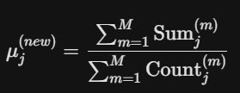

Where $Sum_j^\{(m)\}$ is the sum of vectors assigned to cluster j by worker m.
3.2 Performance Metrics We optimize for the following system metrics:
- Communication Cost ($C_\{comm\}$): The volume of data transferred over the network during the Shuffle phase.
  - Naive Implementation: O (N * d) (Transferring every point).
  - Optimized (Combiner): O (M * k * d) (Transferring only partial sums).
  - Goal: Minimize $C_\{comm\}$ to prevent network saturation.
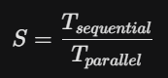
- Speedup (S):

Ideally S ~M (Linear). However, by Amdahl’s Law, the speedup is limited by the serial portion of the code—specifically, the Global Centroid Update performed by the Coordinating Node/Driver.

- Throughput: Measured in records processed per second.
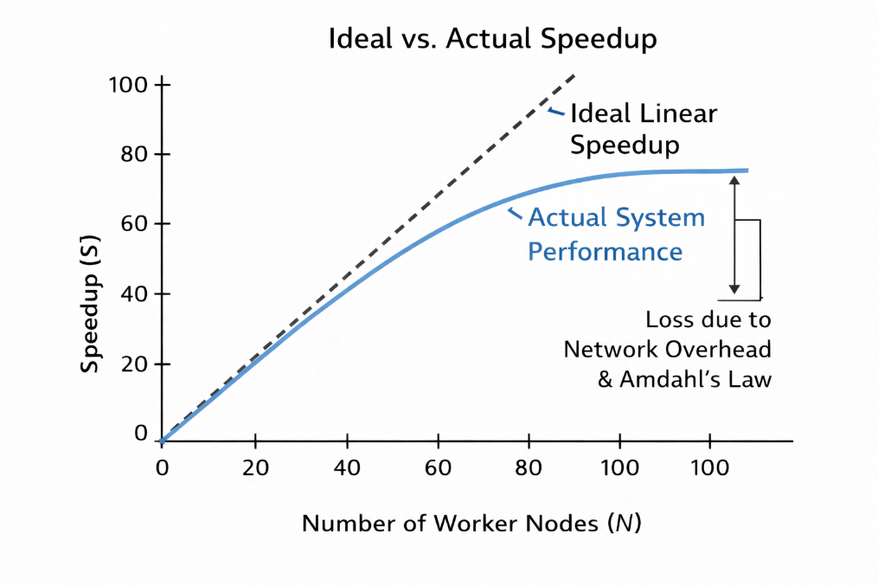

3.3 Runtime Cost Model The total execution time of one iteration of distributed k-means can be modeled as:

$$T_{\left\{iter\right\}}= T_{\left\{compute\right\}}+ T_{\left\{comm\right\}}+ T_{\left\{sync\right\}}$$
Where:
- $T_{\left\{compute\right\}}$represents the parallel distance computation and local aggregation at the worker nodes:
$$T_{\{compute\}} = O(\frac{N.K.d}{M})$$
- $T_{\left\{comm\right\}}$represents the network cost incurred during the shuffle phase:
  - Naive MapReduce: $O(N⋅d)$
  - With Combiners: $O(M⋅K⋅d)$
- $T_{\left\{sync\right\}}$includes reducer execution and driver-side synchronization overhead.
By introducing local combiners, the communication cost is reduced from linear in the dataset size to linear in the number of workers and clusters. This shifts the dominant cost from network communication to parallel computation, enabling near-linear speedup until synchronization overhead becomes significant.

3.4 Assumptions The proposed runtime model and system design are based on the following assumptions:
- The dataset is evenly partitioned across worker nodes, avoiding significant data skew.
- The number of clusters $K$is significantly smaller than the number of data points $N$.
- Cluster centroids ($K×d$) fit entirely in memory and can be efficiently broadcast to all worker nodes.
- Network bandwidth is the dominant bottleneck during execution, compared to computation.
- The Combiner operation is associative and commutative, ensuring correctness of partial aggregation.
- Worker nodes are homogeneous in terms of compute and memory capacity.

4. Initial Design

4.1 System Architecture We propose a Driver-Worker architecture.

- Driver (Coordinator): Holds global state (centroids), checks convergence, and schedules jobs.
- Workers (Mappers): Compute distances and perform local aggregation.
- Reducers: Perform global aggregation.

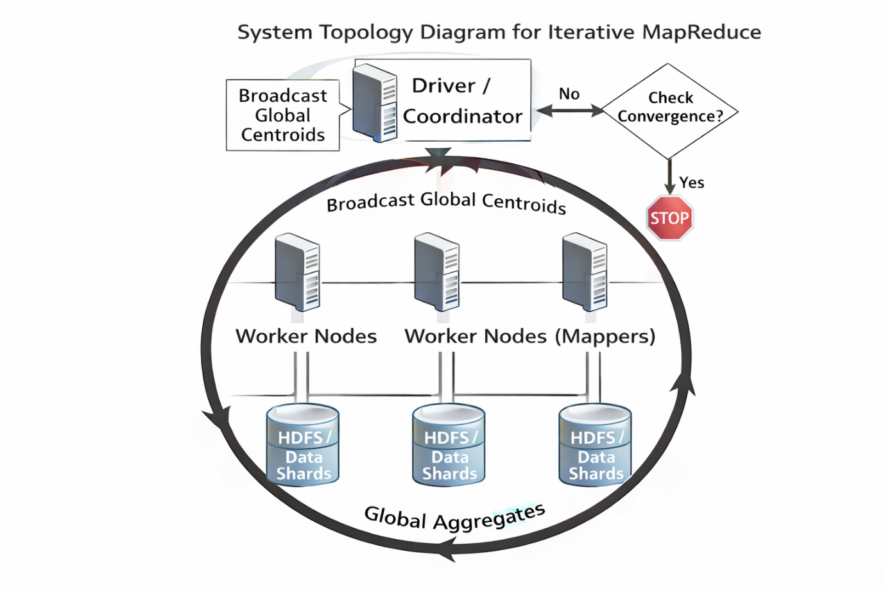

4.2 Distributed Algorithm Logic (with Pseudocode)

The core optimization in our design is the use of a Combiner. Without a combiner, the network is flooded with every single data point. The Combiner performs a local reduction before transmission.
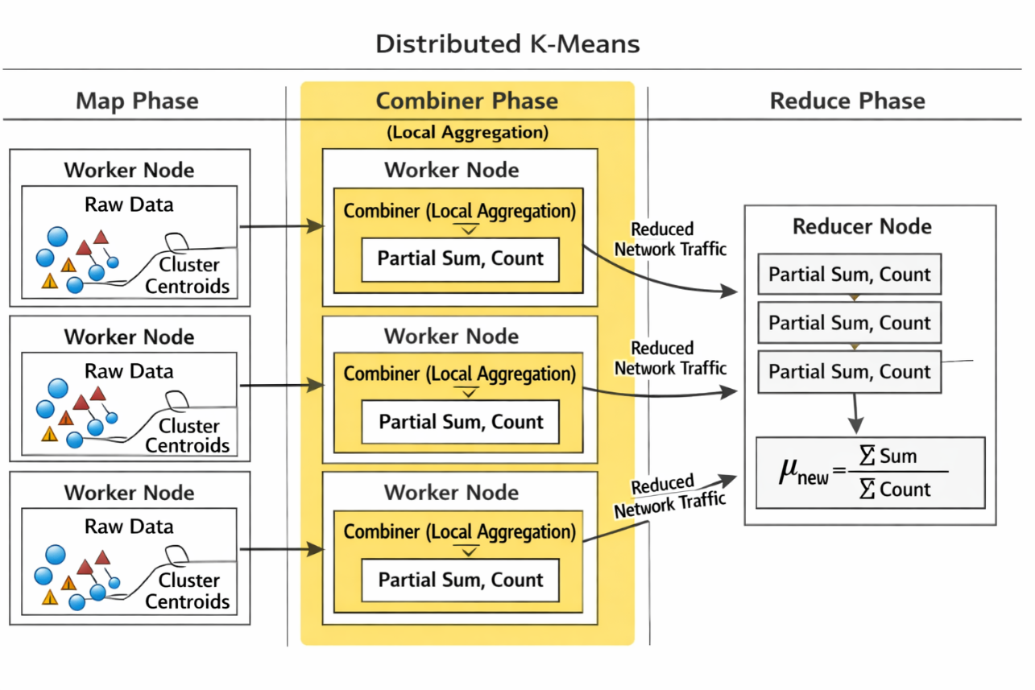
Phase 1: Map (Parallel Distance Compute). Each worker reads a split of data (D_{local}).

def map(key, value: data_point):
# Load global centroids (Broadcast variable)
centroids = load_centroids()
nearest_c_id = find_nearest(value, centroids)

# Emit (Cluster_ID, (Vector, 1))
emit(nearest_c_id, (value, 1))

Phase 2: Combiner (Local Optimization) Crucial Step: Sums vectors locally on the Mapper node to reduce network traffic.

def combine(cluster_id, values):
local_sum = vector_sum([v[0] for v in values])
local_count = sum([v[1] for v in values])

# Emits ONE record per cluster per mapper
emit(cluster_id, (local_sum, local_count))

Phase 3: Reduce (Global Aggregation)

def reduce(cluster_id, values):
global_sum = vector_sum([v[0] for v in values])
global_count = sum([v[1] for v in values])

new_centroid = global_sum / global_count
emit(cluster_id, new_centroid)

Phase 4: Driver Loop
- Broadcast current centroids to all workers.
- Launch MapReduce Job.
- Collect new centroids.
- Calculate shift (Delta). If Delta < Threshold, Stop. Else, Repeat.

4.3 Design Justification

Design Choice | Selection | Justification
Programming Model | MapReduce with Combiners | Standard MapReduce is bandwidth-heavy. Adding Combiners reduces network traffic from $O(N)$ to $O(M \cdot K)$, making the system bandwidth-optimal²².
State Management | Broadcast Variables | Centroids are small ($K \times D$). Broadcasting them is efficient and ensures all Mappers see consistent state.
Straggler Mitigation | Data Partitioning | K-Means is sensitive to data skew. We rely on HDFS block splitting to ensure even data distribution across Mappers.

4.4 Limitations and Trade-offs
While the proposed design significantly reduces communication overhead, it has the following limitations:
- The effectiveness of Combiners depends on balanced data distribution; severe data skew can reduce aggregation efficiency.
- MapReduce incurs disk I/O overhead at the end of each iteration, which can increase runtime for highly iterative workloads.
- The reducer and driver can become synchronization bottlenecks when the number of clusters $K$is large.
- The design assumes homogeneous worker nodes and does not explicitly handle straggler mitigation beyond data partitioning.
These limitations motivate the use of in-memory iterative frameworks such as Apache Spark for production-scale deployments.

5. Conclusion

We have designed a distributed k-means system capable of scaling to massive customer datasets. By mathematically formulating the centroid update as a partial sum aggregation, we identified that Network Bandwidth is the primary bottleneck. Our design addresses this via the Combiner pattern, reducing communication cost by orders of magnitude compared to naive implementations. This ensures the system complies with Amdahl's Law, pushing the bottleneck away from the network and back to the parallelizable computation.

6. References

- MacQueen, J. (1967). Some Methods for Classification and Analysis of Multivariate Observations. Proceedings of the Fifth Berkeley Symposium on Mathematical Statistics and Probability.
- Lloyd, S. (1982). Least Squares Quantization in PCM. IEEE Transactions on Information Theory.
- Dean, J., & Ghemawat, S. (2004). MapReduce: Simplified Data Processing on Large Clusters. Proceedings of the 6th Symposium on Operating Systems Design and Implementation (OSDI).
- Zhao, W., Ma, H., & He, Q. (2009). Parallel K-Means Clustering Based on MapReduce. IEEE International Conference on Cloud Computing.
- Zaharia, M., Chowdhury, M., Franklin, M. J., Shenker, S., & Stoica, I. (2010). Spark: Cluster Computing with Working Sets. Proceedings of the 2nd USENIX Workshop on Hot Topics in Cloud Computing.
- Han, J., Kamber, M., & Pei, J. (2011). Data Mining: Concepts and Techniques. Morgan Kaufmann.
- Aggarwal, C. C. (2015). Data Mining: The Textbook. Springer.

